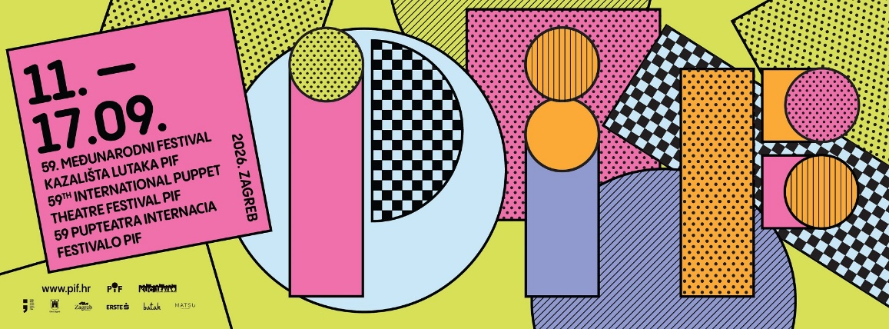

59th PIF: Zagreb Once Again Becomes an International Stage for Contemporary Puppetry and Imagination

From 11 to 17 September 2026, Zagreb will host the 59th PIF - International Puppet Theatre Festival, one of Europe's oldest and longest-running puppetry festivals. Over seven festival days, 13 theatres and artistic companies from nine countries will present contemporary puppetry for children, young people and adults.
The festival that speaks every language will once again open Zagreb's new theatre season. From puppets and animated objects to visual theatre, movement, music and non-verbal performance, the 59th PIF will demonstrate just how diverse, vibrant and exciting contemporary puppetry can be as an art form.

PIF - International Puppet Theatre Festival has been held since 1968. From its Esperanto beginnings, preserved in its original name Pupteatra Internacia Festivalo, it has fostered the idea of universal dialogue, cultural exchange and theatre that transcends linguistic and generational boundaries. Many of this year's performances draw on the universal language of image, body, movement and object animation, making them readily accessible to international visitors to Zagreb.

A Programme for All Generations
The festival will officially open on 11 September at 7 p.m. at the Travno Cultural Centre with "Pierrot's Last Day" by the French company Deraïdenz. This non-verbal production for adults launches this year's programme and confirms that puppetry is by no means an art form intended solely for children.

As the festival week continues, audiences can look forward to appearances by distinguished artists and theatres from Croatia, France, Spain, Uruguay, the Czech Republic, Slovenia, Serbia, Romania and Italy. Programme highlights include "Life" by Spain's Javier Aranda Company, "The Dragon" by Novi Sad Youth Theatre, the Czech productions "The Desert" by Damúza and "Comrades and Circles", "Cankar" by Maribor Puppet Theatre, and "Rags" by Coriolis Object Theatre from Uruguay and Spain.

The programme for young and family audiences features "The Blacksmith's Strange Son" by the Branko Mihaljević Children's Theatre in Osijek, "Julian the Mouse" by Ljubljana Puppet Theatre, "The Adventures of Huckleberry Finn" by Zagreb Puppet Theatre, and "Hedgehog's Home" by Virovitica Theatre. Productions intended especially for older audiences include "Pierrot's Last Day", "The Dragon", "Comrades and Circles" and "Cankar", while Romania's "The Window" offers non-verbal visual theatre for audiences aged 12 and over.

The competition programme concludes on 17 September with the presentation of the festival awards, followed by a performance of "Pinocchio" by the Pinklec Theatre Company.

The Festival Takes to the City Streets
One of PIF's most memorable traditions is the Pifko Parade, which will set off along Tkalčićeva Street at 11 a.m. on 12 September, cross Ban Josip Jelačić Square and finish at Petar Preradović Square. Since 1990, the parade has been led by PIFKO, the festival's monumental mascot, designed and created by artist and professor Mira Dulčić.

This year, PIFKO will once again bring together local and international artists, puppeteers, children, musical ensembles, stilt walkers, giant puppets and numerous residents. The parade is the moment when the festival leaves the theatre auditoriums and becomes part of everyday city life, inviting Zagreb residents and visitors to join in.

A free outdoor programme will also take place at the Zrinjevac Music Pavilion, featuring "The Adventures of Pulcinella" by Italian artist Gianluca Di Matteo, "The Cow on the Moon" by Petra Bokić, "Puppet Revue in Our Town" by the Little Puppeteers from Sisak, "Little Red Riding Hood in Traffic" by Max Theatre, and two productions by the Academy of Arts and Culture in Osijek: "The Other Side of the Fairy Tale" and "Little Red Riding Hood". Performances and workshops will also take place in the park beside the Travno Cultural Centre and on the Mamutica plateau.

The accompanying programme begins as early as 10 September with the opening of the exhibition "Puppet, Mask... PIF", created as part of the 14th children's art competition. The programme also includes puppetry workshops for children, teachers and early childhood educators, as well as older adults, together with initiatives that give a platform to new generations of puppetry artists.

International and Local Partnerships
The festival's international character is further strengthened by partnerships with cultural and diplomatic institutions. The appearance of Javier Aranda Company's "Life" is supported by the Spanish state agency Acción Cultural Española through PICE, its programme for the internationalisation of Spanish culture. The Slovenian theatre appearances are made possible with the support of the Ministry of Culture of the Republic of Slovenia and the Embassy of the Republic of Slovenia in Zagreb, while the appearance by Italian artist Gianluca Di Matteo is supported by the Italian Cultural Institute in Zagreb.

In partnership with the Academy of Arts and Culture in Osijek, PIF presents the programme "Those Who Come Next", featuring students of acting and puppetry. Travno and Potočnica kindergartens, primary schools, and children's and youth puppetry groups are involved in the workshop and performance programmes, enabling the 59th PIF to connect the international arts scene with the local community and educational institutions.

Zagreb as a Festival Stage
The 59th PIF programme will connect New Zagreb with the city centre. Performances will be held at the Travno Cultural Centre, Cultural Information Centre, Zagreb Dance Centre, Zagreb Puppet Theatre and the Polanec Hall of Zagreb Youth Theatre. Outdoor events will take place at the Zrinjevac Music Pavilion, along Tkalčićeva Street, on Ban Josip Jelačić Square and Petar Preradović Square, in the park beside the Travno Cultural Centre and on the Mamutica plateau.

This festival map allows visitors not only to experience outstanding international puppetry but also to discover Zagreb's many faces, from its historic squares and cultural institutions in the city centre to the modernist heritage and green spaces of New Zagreb.

The 59th PIF is organised by the Travno Cultural Centre. The festival is funded by the Ministry of Culture and Media of the Republic of Croatia and the City of Zagreb, and is held with the support of the Zagreb Tourist Board, Erste&Steiermärkische Bank d.d., Batak Grill, Matsu Asian Fusion and Autokuća Štarkelj.

Online tickets have been on sale since 15 August through CoreEvent and the festival website. Outdoor events and performances outside the official competition programme are free of charge.

The full programme and information on performances and tickets are available at www.pif.hr.

From 11 to 17 September, visit the 59th PIF and discover Zagreb as a vibrant international stage - a city where cultures, contemporary theatrical languages and stories without linguistic borders come together.

